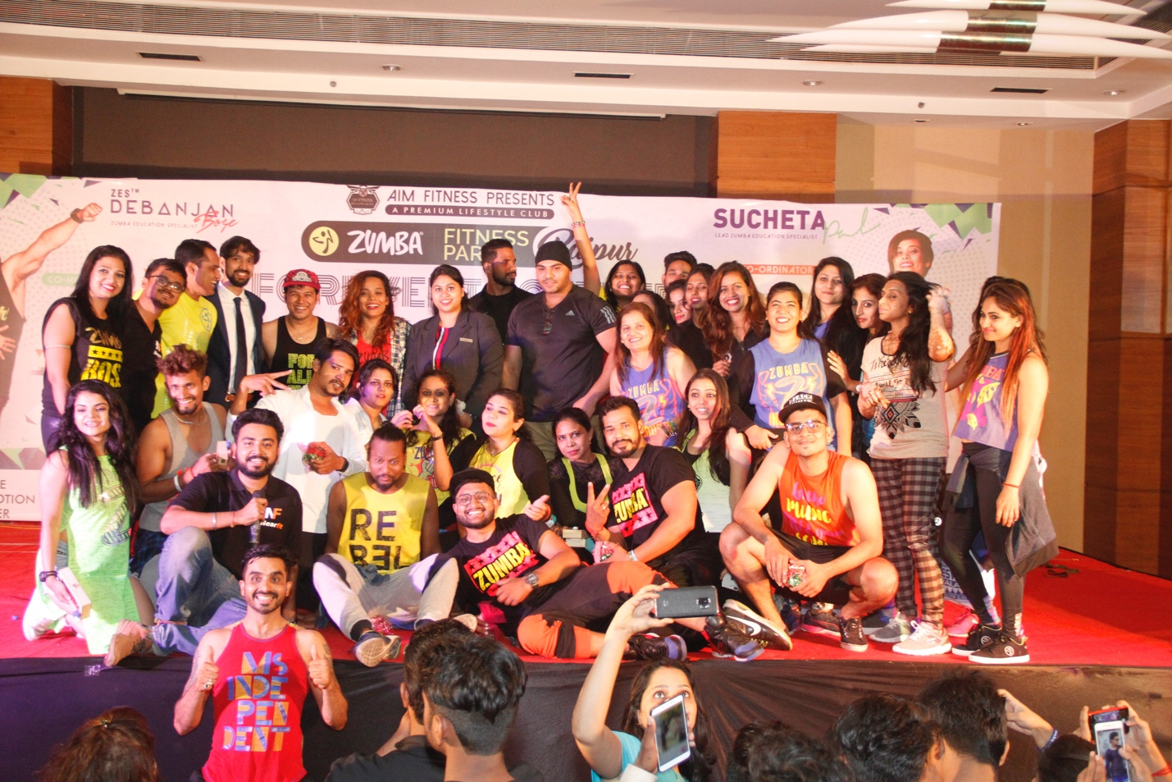

Pic Credits: NEARFIT

**CENTRAL INDIA’S BIGGEST ZUMBA MASTERCLASS**

**ZUMBA Community Chhattisgarh** in association with Nearfit had organised biggest ever Zumba masterclass party of Central India on November 11 at Hyatt Raipur with the novel idea of spreading awareness about Zumba in Raipur and Chhattisgarh region.

**Let’s understand Zumba**

Zumba combines Latin and International music with a fun and effective workout system. Zumba is one of the latest and trending means of getting fit and its growing popularity has taken the country by a storm. Sucheta Pal aka the ‘Diva of Zumba’ is the Ambassador and Education Specialist for Zumba Fitness LLC and was felicitated in 2018 by the President of India as the ‘First Lady’ for women wellness. She is a Zumba International presenter & speaker for top fitness expos and women conferences across the world.

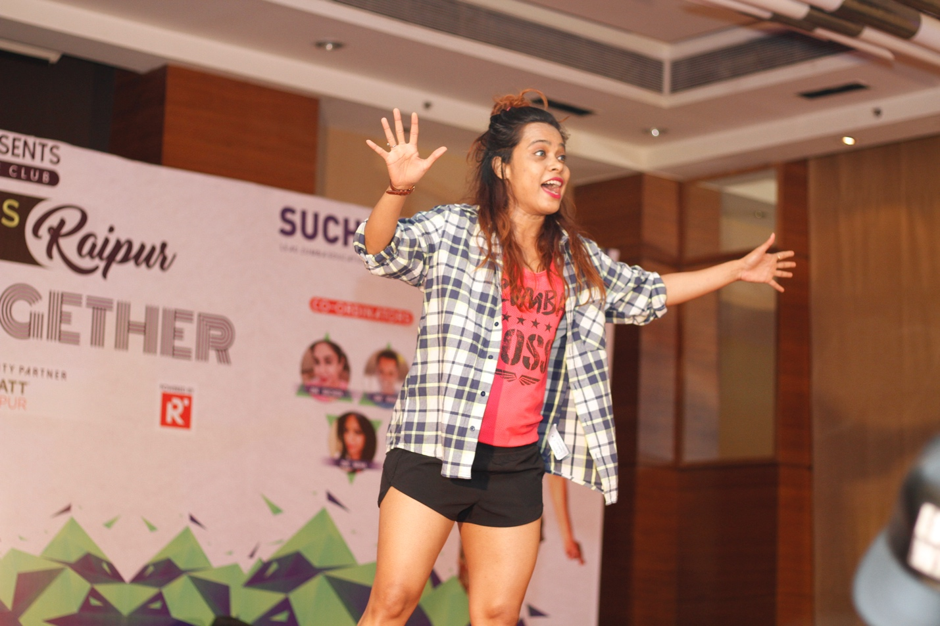

Pic Credits: NEARFIT

**Biggest Zumba party of Central India**

This party, “**Forever together Zumba Party**”- With Sucheta pal (Lead ZES of India) & Debanjan Bose (Zumba Education Specialist) and the ZINS (Zumba Instructors) from Chhattisgarh, Orissa, etc is one of its kind party which combines the global dance styles of Salsa, Tango, Hip- hop, contemporary bolly style with Cardio exercise and is currently a trending form of staying Fit gaining quick popularity among the Indians.

The state of Chhattisgarh is slowly getting into the groove for Zumba, as many young people are now seeing Zumba as an exciting career option to earn as well as stay fit. Zumba Instructors aka ZINS are the rockstars who teach and grow the art of zumba at the grass root levels at various fitness centers and shows.

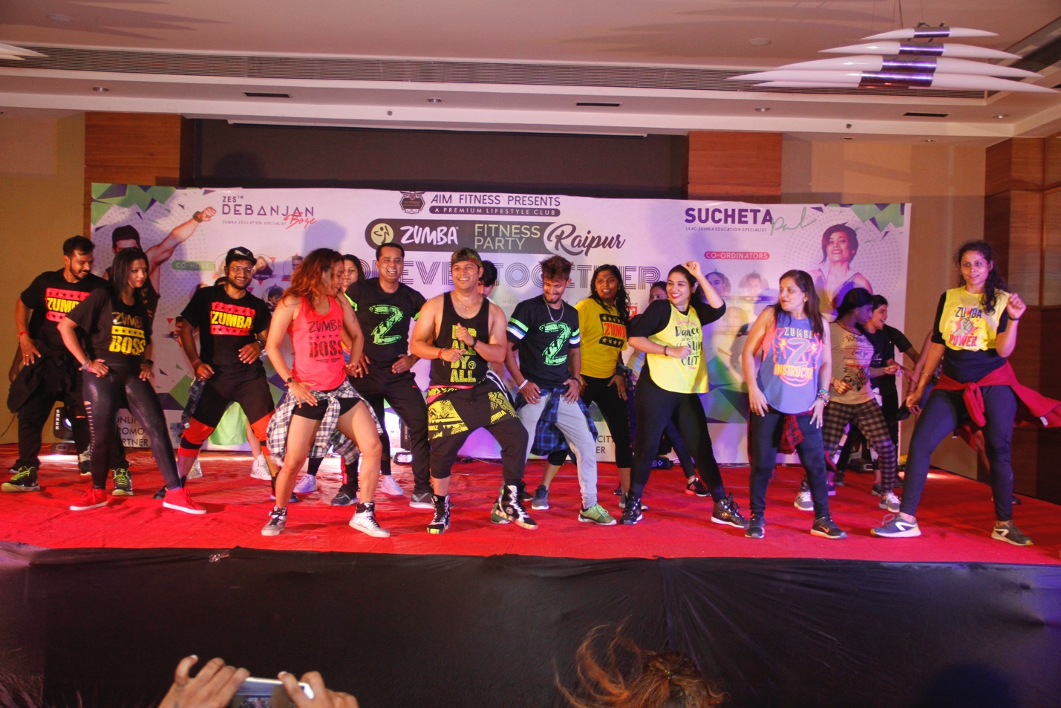

Pic Credits: NEARFIT

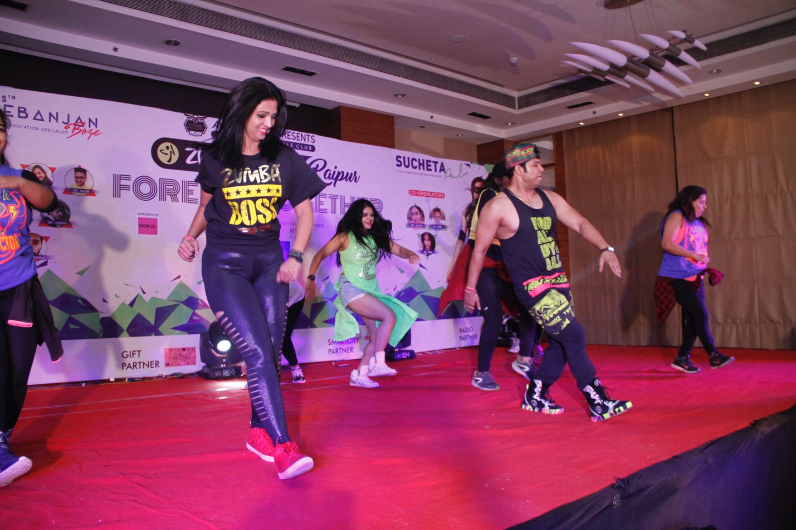

Pic Credits: NEARFIT

For this particular event, there were more than ten Zumba instructors from all over Chhattisgarh and Orissa, who worked hard to make this event happen. They were ZIN Shuchita, ZIN Vivek, ZIN Neha, ZIN Nikita, ZIN Harsh, ZIN Nutan, ZIN Amit, ZIN Gargy, ZIN Prashant, ZIN Amit, ZIN Rajshree, ZIN Geeta, ZIN Akash, etc. Right from setting up an amazing choreography, to making the audience groove to their moves, Zumba is for sure going to be a huge hit in this state.

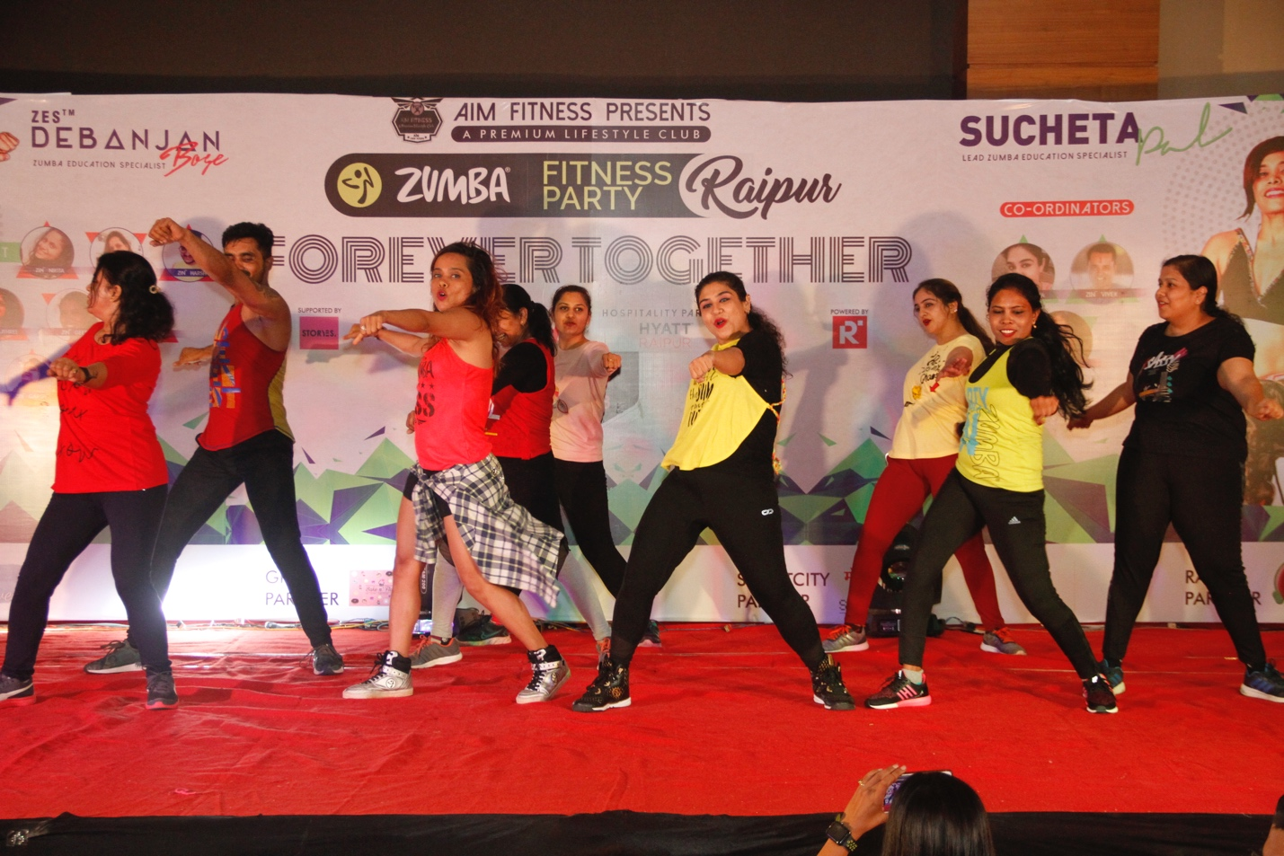

Pic Credits: NEARFIT

**Thanking the sponsors**

Supporting this novel event were AIM fitness – which was the primary sponsor, Storyes Raipur , Reincarnating Raipur, Mor Raipur, Bake and Flake and Hyatt Raipur.

AIM fitness is a premium fitness club and has one of the best infrastructure in Raipur. Storyes is an apparel brand which keeps a wide array of exciting apparels for their clients. Reincarnating Raipur is one of the most happening lifestyle magazine. Bake and flake is an upcoming bakery company and they sponsored all the gifts that were given to the guests.

Hyatt Raipur, who were the hospitality partner for the event, supported whole-heartedly to make this event possible. They provided the best hospitality services to the guests and everyone was quite impressed by their efforts. They also got creative and organised a Healthy theme Brunch which started at noon and then followed by the Fun Zumba at evening.

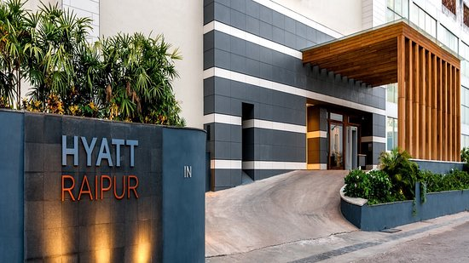

**Pic credits: Hyatt Raipur**

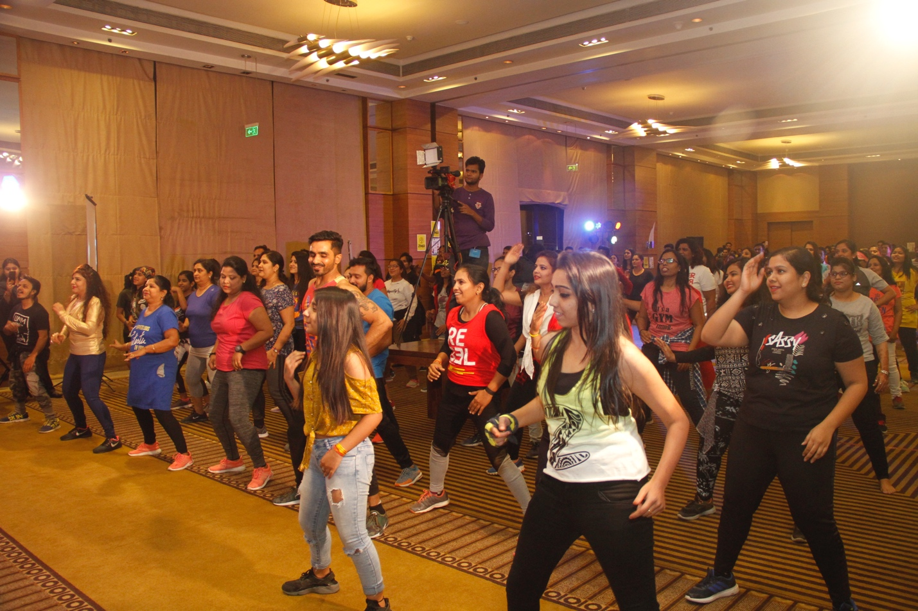

**Pic credits: NEARFIT**

After about Ninety minutes of intense Zumba masterclass, the event was followed by felicitation of all guests. Everyone had an amazing experience and guests left wanting more. We hope such events happen regularly at Chhattisgarh in order to grow the overall community.

In case you want to get in touch with Nearfit, kindly mail us on [office@nearfit.in](mailto:office@nearfit.in) or call us on +91-7001972016. We shall be always happy to help.